**Configuration Management**

This is process of configure of the software’s on the servers remotely

Eg :When we are working on Jenkins install we install of the tomcat on one instance in real time we need to install the same application on 100 server there we use configuration management tool.

**Ansible**

Ansible is **an open source IT Configuration Management, Deployment & Orchestration tool**. It aims to provide large productivity gains to a wide variety of automation challenges. This tool is very simple to use yet powerful enough to automate complex multi-tier IT application environment.

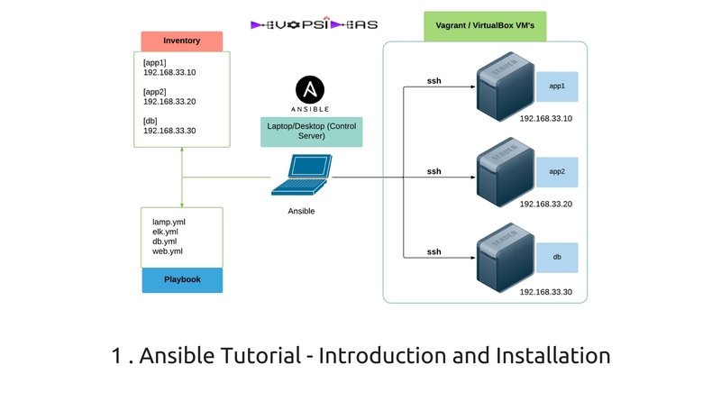

Advantages of ansible

==================

1 Provisioning of Servers

Setup of s/w's on servers can be done very easily from one point

2 Handling Snowflake servers

After a point of time all servers in the data center behave like snowflake servers ie they might be running on slightly different h/w and s/w configuarations.

Configuration Management tools can pick up this info in simple setup file which can be reused to setup similar environments .

Eg : where we can go to north hemisphere and southern hemisphere snow fall

We can take two drops of snow fall has same size and shape etc?

After some condition all the application running on the server1 will behave like a snow flack effect due to some configuration like cpu storage etc

3 Disaster Recovery

In case of disaster recovery where we can loose an entire data center

we can recreate similar data center with greater ease .

Eg: suppose we take bank abc.bank have it data centre in ukarine . due to bomb or natural earthquakes datacentre will be trouble bank has placed there datacentres in different regions.

4 Idempotent

Configuration Management tools are used to bring the servers to a

specific state called as "desired state”, If the remote server is

already in the desired state CM tools will not reconfigure that server.

Eg: We have 20 servers we need to install tomcat 9 and tomcat 8 on each 10 servers but there is a requirement of upgraging the tomcat 8 to tomcat 9 in 10 servers downgrading of tom 9 to tom 8 can be done by the configuration management tools .

5 Reduction of usage of resources

We require less amount of time,money and human resources to configure

servers

Popular CM tools

======================

Ansible ( agent less )

Chef ( it has agent , licenses , chef client )

Puppet

Saltstack

=========================================================

Ansible is installed on one machine that is called as "Controller"

all the remaining servers that we want to configure are called

as "managed nodes/hosts"

Ansible uses "agentless" policy to configure the remote servers

ie we don't require any client side s/w of ansible to be present

on the managed nodes

Ansible uses "push" methodology to push the configuration changes

via passwordless ssh

========================================================

Setup of Ansible

=============================

1 Create 2-3AWS ubuntu instances

2 Name the first one Controller and the remaining as Managed nodes

3 Establish passwordless ssh between Controller and managed nodes

a) **Connect to managed node**

b) Setup password of ubuntu user

sudo passwd ubuntu

c) Edit the sshd_config file

sudo vim /etc/ssh/sshd_config

Search for "PasswordAuthentication" and change it from no to yes

d) Restart ssh

sudo service ssh restart

e) **Connect to Controller**

f) Generate the ssh keys

ssh-keygen

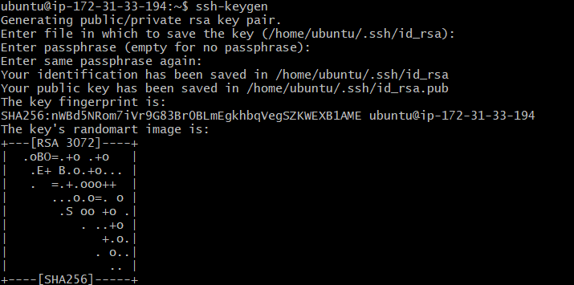

g) Copy the public keys to authoried_keys on managed nodes

ssh-copy-id ubuntu@private_ip_of_managednode

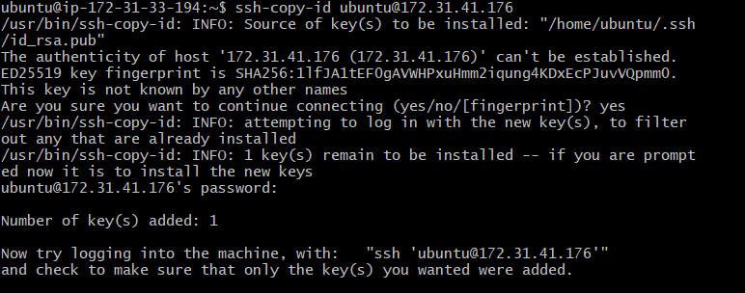

Repeat the above step to connect another managed node

( ssh-copy-id ubuntu@private_ip_of_managednode2 )

4 **Install Ansible**

a) Update the apt repository

sudo apt-get update

b) Install softwares required for ansible

sudo apt-get install software-properties-common

c) Add the latest version of ansible to apt repository

sudo apt-add-repository ppa:ansible/ansible

d) Update the apt repository

sudo apt-get update

e) Install ansible

sudo apt-get install -y ansible

Ansible uses a files known as "inventory" file to read info about the managed nodes, Here we should add the remote managed nodes ipaddress

sudo vim /etc/ansible/hosts

Copy paste the private ip address of all managed nodes

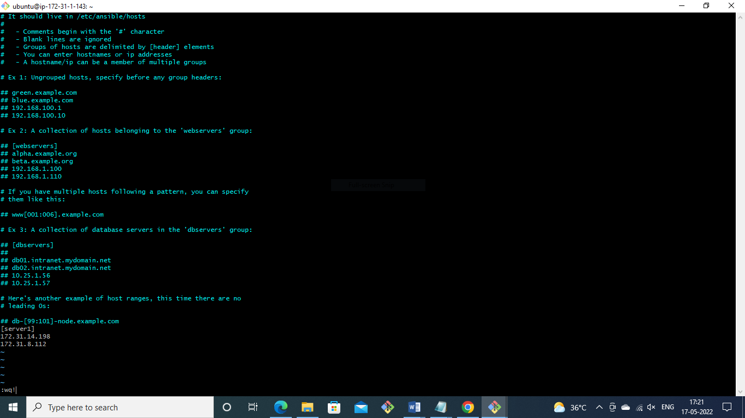

Ansible command to see the memory information of all managed nodes and also check the which are the nodes in active status.

ansible all -i /etc/ansible/hosts -m command -a 'free -m'

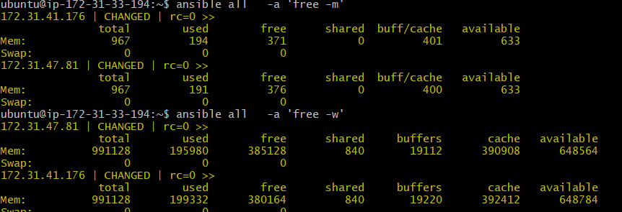

[**https://youtu.be/LJbuKozeA2o**](https://youtu.be/LJbuKozeA2o)